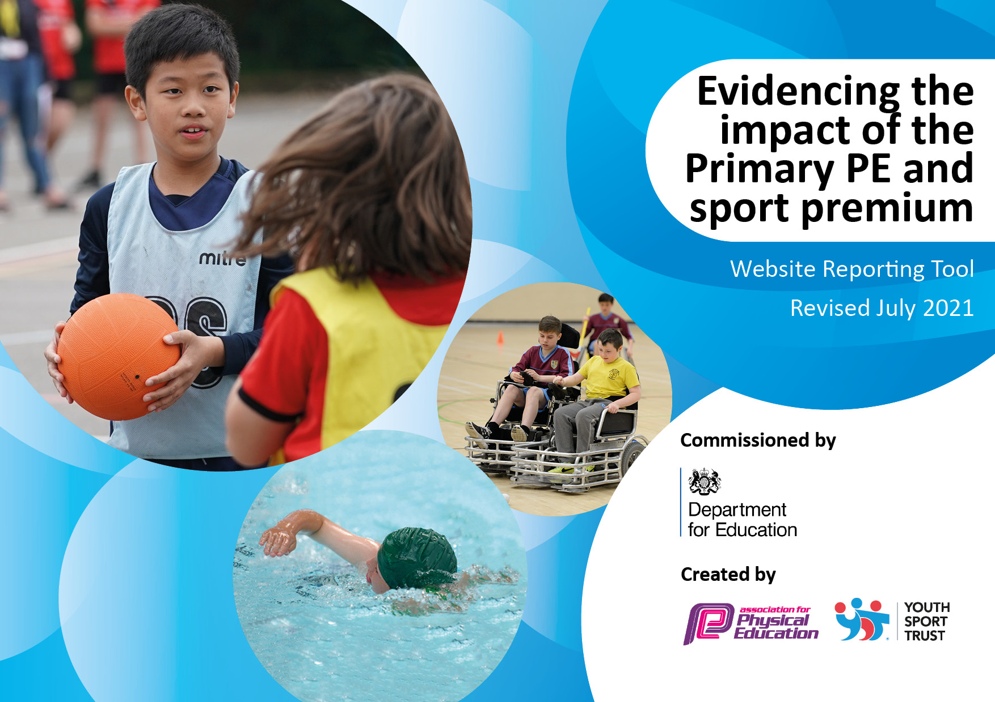

**Bicton C E Primary School and Nursery**



**School Sport and PE Grant: 2023-2024**

**Please see further information in DfE tables on following pages.**

**Funding received:**

Each year the school receives additional money from the government to support this area. In the academic year 2023-2024, Bicton was allocated £17,133

**How it has been spent:**

Funding has been allowed to allow our PE / extra-curricular staff to fulfil their roles:

Key elements of these roles include:

- Competitive Sport: taking a lead role in co-ordinating our involvement in a wide variety of sporting competitions, including sourcing opportunities to collaborate with other schools.

- Curriculum: providing support for colleagues in the delivery of high quality PE, including attending training and sourcing CPD and resources for colleagues.

- Extra-Curricular Sports Clubs: designing our programme of clubs, commissioning staff and managing this important area.

The school has used the funding to enhance our extra-curricular sports provision.

- The school is committed to giving children the widest possible access to sport.

- Our sport clubs are run by a combination of teaching assistants and external coaches. This year, we further increased our range of extra-curricular range of sports and providers who provide positive role models to our pupils.

Some of our finance is used to support participation in inter-school sports competitions.

- Some of the costs of releasing staff to facilitate participation in these events are met from the sports premium.

- Some additional costs associated with these events e.g. entry fees, transport costs and purchase of school kits are also funded from the sports premium.

**The impact of the funding on pupils’ PE and sport participation and attainment in 2023-24:**

- Increased uptake at all sports clubs for ages 3 to 11.

- High quality PE and sports provision within school.

-Increased participation in inter-school PE competitions

**How the improvements will be sustainable in the future:**

- Some of our sporting activities / provision involves a member of our school staff working alongside an external sports coach or PE specialist. This provides valuable CPD for staff and over time will increase ‘in house’ expertise, as well as ensuring that the provision can be sustained if the funding was reduced or removed in the future.

**Details with regard to funding**

|  |  |
| --- | --- |
| Total amount carried over from 2022/23 | **£ 1,393** |
| Total amount allocated for 2023/24 | **£17,133** |
| Total amount of funding for 2023/24. To be spent and reported on by 31st July 2024. | **£18,526** |

**Swimming Data**

|  |  |
| --- | --- |
| **Meeting national curriculum requirements for swimming and water safety.** | |
| What percentage of your current Year 6 cohort swim competently, confidently and proficiently over a distance of at least 25 metres? | 82% (18/22) |
| What percentage of your current Year 6 cohort use a range of strokes effectively [for example, front crawl, backstroke and breaststroke]?  Please see note above | 73% (16/22) |
| What percentage of your current Year 6 cohort perform safe self-rescue in different water-based situations? | 73% (16/22) |
| Schools can choose to use the Primary PE and sport premium to provide additional provision for swimming but this must be for activity **over and above** the national curriculum requirements. Have you used it in this way? | No |

**Action Plan and Budget Tracking**

Capture your intended annual spend against the 5 key indicators. Clarify the success criteria and evidence of impact that you intend to measure to evaluate for pupils today and for the future.

|  |  |  |  |  |
| --- | --- | --- | --- | --- |
| **Academic Year:** 2023/2024 | **Total fund allocated:** | **Date Updated:** July 2024 | |  |
| **Key indicator 1:** The engagement of all pupils in regular physical activity – Chief Medical Officers guidelines recommend that primary school pupils undertake at least 30 minutes of physical activity a day in school | | | | Percentage of total allocation: |
| 10% |
| **Intent** | **Implementation** | | **Impact** |  |
| *Your school focus should be clear what you want the pupils to know and be able to do and about what they need to learn and to consolidate through practice* | *Make sure your actions to achieve are linked to your intentions* | *Funding allocated* | *Evidence of impact: what do pupils now know and what can they now do? What has changed?* | *Sustainability and suggested next steps* |
| Our broad and balanced PE curriculum offer will help pupils:   * develop physical competence to   enable them to excel in a range of competitive sports and physical activities   * be physically active for sustained   periods of time   * develop the necessary skills to allow   them to plan and evaluate physical performance   * understand the benefits of physical   activity to health and general wellbeing   * encourage them to lead healthy   and active lives   * assess their own and others’ safety * develop their interpersonal skills * develop problem solving skills * increase in self-esteem /confidence * enjoy and gain satisfaction from   skilful physical activities | Extended the range of after-school clubs offered, to encourage more pupils to take part in physical activity.  (Extending and funding attendance of school sports clubs and activities or broadening the range of sports/activities offered continues to be a key focus for our school.)  Improved our dance provision through lessons delivered by a fully qualified dance teacher in Upper Key Stage 2  Bikeability sessions for pupils in Upper Key Stage 2. | £1938 | Pupil voice continues to show improved wellbeing and attitudes towards physical activity. Pupils are physically active for longer periods of time.  Increased take-up of extra-curricular activities - funded and part-funded places - as follows:  Football: Reception to Year 2  Year 3 to 6  Multi sports: Year 1 to Year 6  Dance: Nursery to Year 6  Forest School / Wildlife Watch: Year 1 to Year 6  This has enabled more children to access regular outdoor activity. LKS2 pupils have continued to experience regular outdoor learning sessions with the Leader which has improved their wellbeing. It also inspired some to attend Wildlife Watch after-school club and / or pursue outdoor physical activities outside school. | Re-introduce EYFS Balance bike (Learn to Ride) sessions. Arrange Balance Bike CPD for EYFS staff in Autumn term 2024.  Health and Wellbeing Council to survey pupils to ensure our extended school offer continues to meet pupils’ interests and identify other sports to introduce.  Extend Forest School provision by delivering sessions across the school, to encourage regular outdoor activity. This will allow all year groups to experience being active in a range of situations and environments.  50% of in-house PE sessions to be delivered by a member of staff with specific qualification in the delivery of PE and school sport. |
| **Key indicator 2:** The profile of PESSPA being raised across the school as a tool for whole school improvement | | | | Percentage of total allocation: |
| 65% |
| **Intent** | **Implementation** | | **Impact** |  |
| *Your school focus should be clear what you want the pupils to know and be able to do and about what they need to learn and to*  *consolidate through practice* | *Make sure your actions to achieve are linked to your intentions* | *Funding allocated* | *Evidence of impact: what do pupils now know and what can they now do? What has changed?* | *Sustainability and suggested next steps* |
| As Key indicator 1 | Building on the work of the PlayMaker Primary Leaders scheme, Year 6 pupils will continue to offer a range of sports clubs for younger children to access during lunchtimes.  (Sports Leaders UK)  Subject leader released to observe / monitor participation across the school / cover events, complete action plans for PE and School sport, etc.  Role of Sports Captains embedded – continued to celebrate pupils’ successes and achievements in PE and sport across the school.  School Sport apprentice position continued to provide a positive role model to pupils and encourage more pupils to want to take up sport. | £0  £200  £132  £11,727 | This has promoted physical activity and encouraged more children to be involved in activity from a younger age. The Year 6 Sports Leaders’ confidence and self-esteem has risen, improving their wellbeing and interpersonal skills. They have been positive role models to younger pupils and taking on additional responsibilities has improved outcomes in other areas of the curriculum.  Profile of PE and sport is raised across the school. Curriculum plan updated with clear progression of knowledge and skills evident.  Subject leader reported to governing body regularly to share action plan.  Pupils’ achievements celebrated in end-of-week celebration assemblies, which has provided encouragement and engaged more pupils with sports. Weekly newsletters on school website have included competition feedback, forthcoming events and links with local providers, to aspire children to be more involved in sports.  Employing a School Sport apprentice has provided a positive role model to pupils. Provision has allowed us to enter more competitions and monitor pupil participation. Member of staff has coordinated physical activities at lunch times, including coaching of Year 6 leaders to develop their skills and independence in leading these activities, provided targeted activities or support to involve and encourage the least active children and encouraged active play during break times and lunchtimes across KS1 and KS2. | Continue Year 6 Sports Leaders work and introduce with Year 5s.  Introduce in-house playtime leaders’ scheme for younger pupils in Year 4, to ensure sustainability going forward, encourage / enhance their participation in sport and improve their learning behaviours.  Liaise with feeder secondary schools to identify opportunities for KS4 pupils to work alongside school staff at after-school sporting clubs. Survey pupils on sports they participate in outside school – are there opportunities are for incorporating other sports in our curriculum offer? |

|  |  |  |  |  |
| --- | --- | --- | --- | --- |
| **Key indicator 3:** Increased confidence, knowledge and skills of all staff in teaching PE and sport | | | | Percentage of total allocation: |
| 20% |
| **Intent** | **Implementation** | | **Impact** |  |
| *Your school focus should be clear what you want the pupils to know and be able to do and about what they need to learn and to*  *consolidate through practice* | *Make sure your actions to achieve are linked to your intentions:* | *Funding*  *allocated* | *Evidence of impact: what do pupils now know and what can they now do? What has changed?* | *Sustainability and suggested* |
| *next steps* |
|  |
|  |
|  |
| As Key Indicator 1 | P.E. network meetings / CPD attended.  PE specialist (Embrace PE) employed to deliver 2 x hour per week.  Sports Partnership – The Corbet School  New *PE planning* scheme implemented to ensure consistency in delivery and clear steps of progression across different areas of PE.  Collaborated with Shrewsbury Town in the Community through *Reading the Game* programme | £80  £2320  £839  £400 | In-house CPD through working alongside / observing other professionals has improved teacher confidence.  The Corbet School Sports Coordinator and School Games Organiser broadened the range of competitive inter-school sports competitions this year. Staff shared CPD in the initial planning meeting. By linking with other schools, pupils developed their social skills and confidence in different settings and shared their enjoyment of sport in safe environments. This also supports with transition to secondary school through participating against pupils from other feeder primary schools.  PE planning has increased staff expertise and improved pupil outcomes.  RTG has developed staff confidence and provides positive role models to pupils. | Identify any CPD needed for PE subject leader in 24-25.  Some of our after-school clubs / activities involve external sports coaches or PE specialists. Over time, staff confidence and expertise continue to grow. This will build capacity if financial restrictions require us to reduce the involvement of external professionals in the future.  Staff expertise and confidence has improved through use of *PE planning* and we will no longer employ PE specialists (Embrace PE) to deliver curriculum lessons.  Continue with RTG in 24-25 with Year 3 and Year 4. |
| **Key indicator 4:** Broader experience of a range of sports and activities offered to all pupils | | | | Percentage of total allocation: |
| 3% |
| **Intent** | **Implementation** | | **Impact** |  |
| *Your school focus should be clear what you want the pupils to know and be able to do and about what they need to learn and to*  *consolidate through practice* | *Make sure your actions to achieve are linked to your intentions* | *Funding*  *allocated* | *Evidence of impact: what do pupils now know and what can they now do? What has changed?* | *Sustainability and suggested*  *next steps* |
| * develop physical competence to enable them to excel in a range of competitive sports and physical activities * be physically active for sustained periods of time * develop the necessary skills to enable them to plan and evaluate physical performance * understand the benefits of physical activity to health and general wellbeing * encourage them to lead healthy and active lives * assess their own safety and that of others * develop their interpersonal skills * develop problem solving skills * increase in self-esteem and confidence * enjoy and gain satisfaction from skilful physical activities | Additional equipment purchased to support teaching and delivery of PE and sports:  Dodgeballs  Footballs (range of sizes)  Rounders equipment  Sports day equipment  Skipping ropes  Basketball hoops  Tennis Balls | £522 | A refreshed and wider range of equipment has inspired pupils to be more active during break times and increased variety of after-school sporting clubs offered. | Audit equipment alongside pupil survey to identify further resources needed.  Monitor equipment quality and storage system – is it in good quality, and being cared for and stored appropriately? |

|  |  |  |  |  |
| --- | --- | --- | --- | --- |
| **Key indicator 5:** Increased participation in competitive sport | | | | Percentage of total allocation: |
| 3% |
| **Intent** | **Implementation** | | **Impact** |  |
| *Your school focus should be clear what you want the pupils to know and be able to do and about what they need to learn and to*  *consolidate through practice* | *Make sure your actions to achieve are linked to your intentions* | *Funding*  *allocated* | *Evidence of impact: what do pupils now know and what can they now do? What has changed?* | *Sustainability and suggested* |
| *next steps* |
|  |
|  |
|  |
| * develop physical competence to   enable them to excel in a range of competitive sports and physical activities   * be physically active for sustained   periods of time   * develop the necessary skills to   enable them to plan and evaluate  physical performance   * understand the benefits of physical activity to health and general wellbeing * encourage them to lead healthy and active lives * assess their own safety and that of others * develop their interpersonal skills * develop problem solving skills * increase in self-esteem and confidence * enjoy and gain satisfaction from   skilful physical activities | Wider range of sporting events and competitions entered across both KS1 and KS2 – subject leader and staff release time to carry out administration tasks for all sports events – entries, parental consent, risk assessments, etc.  Provision of transport to competitive events off site | £100  £440 | Increased participation for all groups and ages of pupils across a range of sports competitions and events around Shropshire. This will support them in developing healthy lifestyle choices as they grow up.  Links established with schools outside cluster, which further developed pupils’ interpersonal skills. Through these links, more sport can be offered on a competitive or a friendly basis which will contribute to raising achievement for pupils across age groups.  Wider range of our staff attended events, providing them with valuable CPD. | Begin gathering evidence to reapply for School Games Mark in 2024-2025.  Continue to develop and explore links with other schools – range of inter-school events between cluster schools arranged for 24-25.  Continue to enter a wide range of competitive events and ensure all groups of pupils are represented. |

|  |  |
| --- | --- |
| Signed off by | |
| Head of School: | Eleanor Mavin |
| Date: | 18.07.24 |
| Subject Leader: | Eleanor Mavin |
| Date: | 18.07.24 |