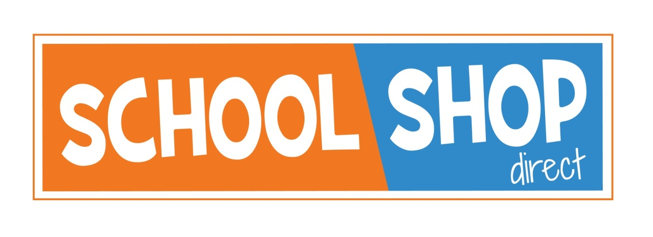
We know how important and exciting it is to be choosing your new uniform when starting at school, and we are here to help.
Due to Covid 19 we want to help everyone to access their new uniform in a safe and controlled way. For Summer 2020 we will be making a few changes and additions to how we serve our customers
ON-LINE – The on-line shop is fully open – We strongly advise buying on line this summer. Orders can be delivered directly to your address. In addition, we will be offering a collect from store service. This will show as available on our website once government guidance allows.
To aid social distancing, collect from store orders will only be available for collection once you have been contacted to say your order is ready, on arrival you will see a collection point.
Please allow up to 7 days for collect from store – as we need to manage the number of people arriving to maintain distancing.
Last date for Online orders for back to school - Friday 14th August 2020.
SHOP – The shop will be open as normal; we are awaiting government guidance on the exact date for re-opening. But to maintain distancing, fewer customers will be able to be in the shop at one time. We STRONGLY advise that this year customers shop as early as possible.
Please see our website for up to date opening details.
APPOINTMENTS – For pupils starting a new school we will be offering appointments, on Sundays, from Sunday 19th July, again subject to government guidance, to allow more time to try items on etc. We do recommend booking this as soon as possible as it is likely to be a popular option.

We thank you for your help with planning uniform early this summer, so that we can offer everyone a safe environment.
For any queries and help please do contact us:

17-18 Sundorne Trade Park, Featherbed Lane, Shrewsbury, SY1 4NS
Telephone: 01743 440449
E-mail: info@schoolshopdirect.co.uk
www.schoolshopdirect.co.uk

