**Suggestions for EY parents to support with home learning environments**

**Matching activities**

Matching activities encourage children to observe carefully, to use their memory and to use their language to communicate. All these are essential foundations for the later skills of reading, writing and maths.

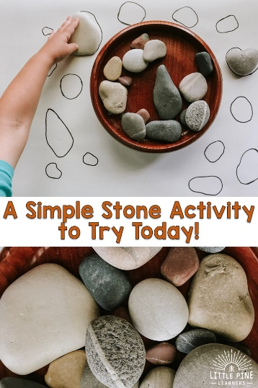

Using stones, this is a simple activity, that not only requires careful observation but naturally prompts a discussion about the properties of the stones.  
”This game will give your child the opportunity to practice using new vocabulary words, compare different sizes and shapes, strengthen fine motor skills, and appreciate nature in a new way.”

<https://littlepinelearners.com/a-simple-stone-activity-to-try-today/>

You could also match socks. Gather various sized socks from family members, put one of the pair into a bag/box and keep the other one out. Take the opportunity to talk about whose socks they are, the patterns on them and how many did you match.

Take photos from an unusual angle of common objects around the house (or garden), show the picture to your child, can they find the object?

Draw simple pictures or shapes onto squares of paper, make sure you always do two. Turn them face-down and play the traditional matching game. This one is particularly good for developing memory skills.

**Feelings**

The game below is from a Portuguese Facebook site “Nil, Professora da Educacao infantile”, there is no website. But it is such an easy resource to make and allows the child to think and express their emotions, particularly relevant in todays climate. The adult can support this by adding the correct words to describe the emotion

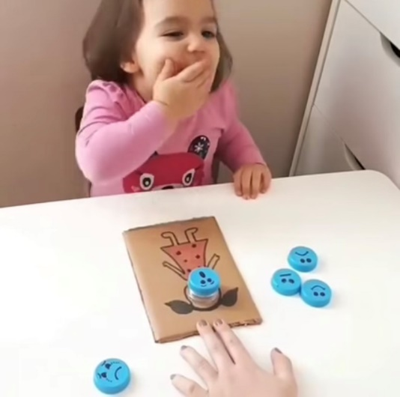

The neck and top of a plastic bottle are placed through a hole cut into the cardboard. More tops are collected. On the cardboard draw a person leaving the cut out hole for their face. On the bottle tops draw a range of simple faces showing a variety of emotions. The child chooses one that suits their mood and puts it in the correct place.

**Sharing stories**

At a time when all libraries and bookshops are closed there couldn’t be a better resource than someone reading a story. The link below takes to you a site where the “top ten stories to enjoy” are read out. They might be old favourites or new stories to become favourites and to look out for once we are allowed to go back into our libaries.

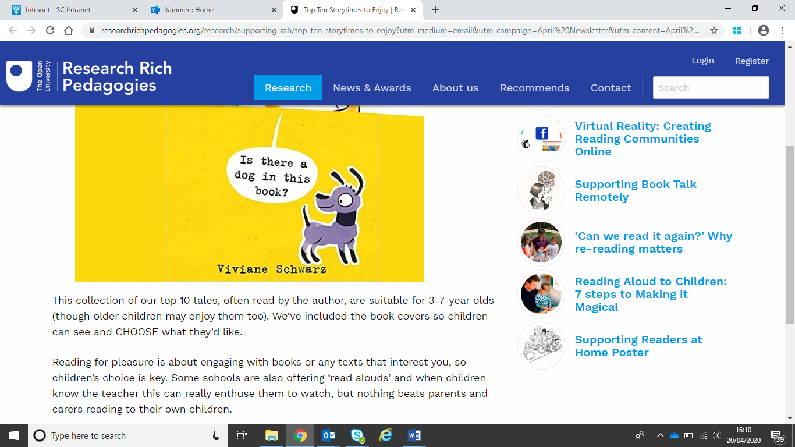

<https://researchrichpedagogies.org/research/supporting-rah/top-ten-storytimes-to-enjoy?utm_medium=email&utm_campaign=April%20Newsletter&utm_content=April%20Newsletter+CID_986c9924e19a3eefe80b4ceb91cfeed3&utm_source=EmailCampaign&utm_term=Top%20Ten%20Storytimes>

**Tiny Happy People**

**Your words build their world**

“Tiny Happy People is here to help you develop your child’s communication skills. Explore our simple actiivities and play ideas …”

There are lots of ideas on this website for parents to do with their young children. Below are just a few examples, they all have accompanying videos

www.bbc.co.uk/tiny-happy-people/

**3-6 months**

**Ready steady go**

**'Ready...Steady...Go!' games are great for building your baby's attention and listening skills.**  
Build their excitement for all sorts of things, from blowing bubbles, to rolling a ball, or blowing a raspberry, by using the words 'Ready...Steady...'.Before you say 'Go!', wait for your baby to make a noise or gesture to show they are ready.This will encourage them to show you what they want to happen  
<https://www.bbc.co.uk/tiny-happy-people/ready-steady-go/znq6kmn>

**18-24 months**

**Shopping game**

**Pretend play can help your little one understand everyday life.**  
Try a shopping game with objects from around your home and give your child the chance to use new words and follow simple instructions.  
<https://www.bbc.co.uk/tiny-happy-people/shopping-game-18-24/zbhyf4j>

**2-3 years**

**How to make your own binoculars  
Have a look out the window and see what you and your little one can spot through these binoculars.**You can play a game of eye spy, or just follow your little one's lead. The more you play, the more you can build up their vocabulary with describing words.  
 <https://www.bbc.co.uk/tiny-happy-people/how-to-make-binoculars/zb33bdm>

**3-4 years**

**Colour theme your day**

**Enjoy a colour-themed day with your little one.**  
Once you've decided on a colour together, choose clothes and foods that are this colour and encourage your child to notice things that are the colour of the day. It's a fun way to learn colours and to build their vocabulary.  
<https://www.bbc.co.uk/tiny-happy-people/colour-theme-your-day/z77bbdm>

**4-5 years  
Putting things in order**

**Sorting objects into a row - from big to small or light to heavy - is a really great way to develop your child's communication and reasoning skills.**

Encourage your child to explain what they are doing at each step. Try using measure words like, 'bigger' or 'biggest' when sorting.