Suggestions for EY parents to support with home learning environments

Grow your own food
There are lots of ideas on this website.
Take a look and enjoy growing a variety of fruit and vegetables.
https://www.diyncrafts.com/4732/repurpose/25-foods-can-re-grow-kitchen-scraps

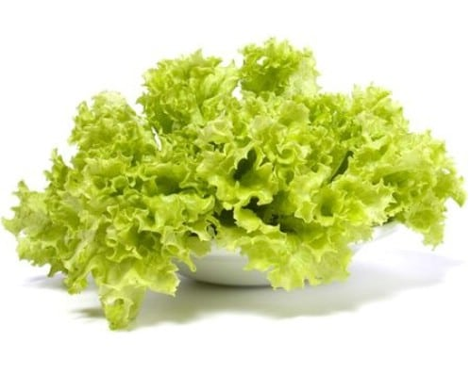
Lettuce, Bok Choy and cabbage are relatively easy to grow from scraps. Instead of throwing out those leftover leaves, simply place them in a bowl with just a bit of water in the bottom. Keep the bowl somewhere that gets good sunlight and mist the leaves with water a couple of times each week. After 3 or 4 days, you will notice roots beginning to appear along with new leaves. When this happens you can transplant your lettuce or cabbage in soil

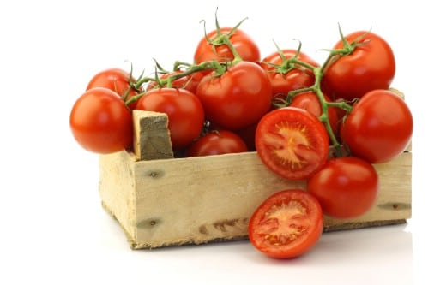
Tomatoes can be grown just by saving those seeds that you probably throw out anyway. You just have to rinse the seeds and allow them to dry. Plant in a good, rich potting soil until you notice growth coming in. Allow the seeds to get a few inches high before transplanting them outdoors. During cold weather you can grow your tomatoes indoors. Just remember to keep them in an area that gets plenty of sunlight and water a few times each week

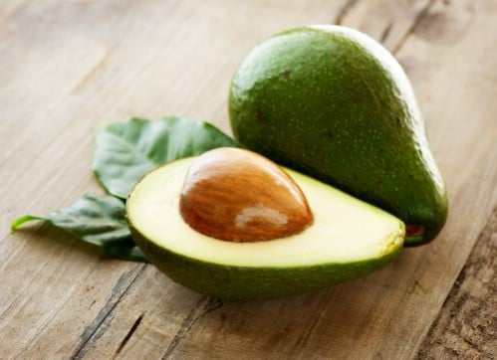
Avocado seeds can be used to grow a steady supply of this super food. You just have to wash the seed and use toothpicks to suspend it over water in a bowl or jar. The water should come up enough to cover the bottom inch of the seed. Keep the container in a warm place but not in direct sunlight and remember to check the water every day and add more as needed. It can take up to six weeks for the stem and roots to appear and once the stem reaches about 6 inches you will need to cut it down to 3 inches. When leaves begin appearing, you can plant the seed in soil, remembering to leave about half of it above ground

Loose Parts
“A ‘loose parts’ tool, is open-ended; children may use it in many ways and combine with other loose parts through imagination and creativity.
Nature which excites all the senses, remains the richest source of loose parts.”
Richard Louv, Author
Take a look at this website to get lots of ideas for loose part play.
https://www.playscotland.org/parents-families/loose-parts-play/

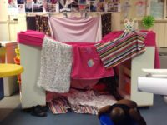
Den Building
You can use: sheets, blankets, beach towels, cushions, cardboard boxes and a good idea to clip them together is to use pegs.
You can use chairs indoors and outdoors to make the structure, or large bits of woods and make a tepee.
Scatter the cushions and pillows on the floor to make the ground cosy.

Tiny Happy People
Your words build their world
“Tiny Happy People is here to help you develop your child’s communication skills. Explore our simple actiivities and play ideas …”
There are lots of ideas on this website for parents to do with their young children. Below are just a few examples, they all have accompanying videos
www.bbc.co.uk/tiny-happy-people/

0-12 months
Bathtime fun
Chatting at bath time is a fun way to help boost your baby's language development during a busy day.
Try naming different body parts as you wash and splash away!
https://www.bbc.co.uk/tiny-happy-people/bath-time/z77qjhv?dm_i=3YNL,14CL5,5TQZY9,3XWTN,1

6-18 months
What’s in the bag
Looking for a fun game to play at home?
Take a pillowcase and fill it with ordinary items.
Your child will love the surprise of what you pull out and name.
https://www.bbc.co.uk/tiny-happy-people/whats-in-the-bag-haifa/zjkdy9q?dm_i=3YNL,14CL5,5TQZY9,3XWTN,1

8-24 months
I can cook
Everyday tasks like cooking can be a great chance to talk to your baby about different things. You can build their vocabulary by introducing them to different words for foods and textures.
If it's safe, try giving them a little of each food so they can explore the way they feel and taste.
https://www.bbc.co.uk/tiny-happy-people/i-can-cook/zf26mfr?dm_i=3YNL,14CL5,5TQZY9,3XWTN,1

2-3 years
Skittles
Playing homemade skittles out of household objects improves your toddler's coordination and communication skills.
You could use rolled-up socks as the ball, and empty bottles or toilet roll tubes as the skittles - remember to recycle them afterwards!
Encourage your little one to describe what they are doing and you can count the remaining skittles together.
https://www.bbc.co.uk/tiny-happy-people/homemade-skittles/zjq6xyc

3-4 years
Memory games

Memory games about everyday situations are lots of fun and a great way to help your little one build sentences.
Take turns remembering what you bought at the shops or what you saw on walk.
https://www.bbc.co.uk/tiny-happy-people/play-memory-games/zmq3382

