[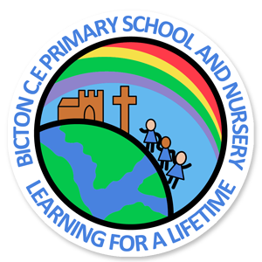](http://www.bictonschool.org.uk/index.php)

**What to Remember**

Spellings: At the end of next week, each child will be given a spelling book with a set of spellings to learn. Spelling tests will be on Fridays, and the spellings will be linked to the phonics we are learning in class.

Homework: Homework will be set as and when, relating to different areas of the curriculum.

Reading Books: Please make sure your child reads their reading book regularly at home and write a small comment in their reading record. Please ensure reading records are in school every day. We will listen to your child read at least once a week either 1:1 or in a group guided reading session.

PE: PE will be on **Thursdays** this term taught by Mr Sudlow. Please ensure PE kit is in school on this day.

Website: Remember our Class 2 page can be found following the links on the school website. This will be updated regularly with photographs and important information.

**Welcome back!**

**I hope you have all had a lovely summer holiday. We are looking forward to a busy and exciting term in Class 2.**

**Class 2 Staff**

**Mr Mavin – Class teacher**

**Mrs Law – Teaching assistant**

**Mrs Hughes – Teaching assistant**

English

In English we will be following the Read Write Inc program for phonics and English. This incorporates phonics, handwriting, guided reading, spelling and independent writing. The children will have many extended writing opportunities over the term.

We will also be focussing on using capital letters, full stops, finger spaces and adjectives.

Maths

In maths we will begin with looking at the place value of numbers and how they can be represented in different ways. We will then move on to addition and subtraction skills.

Science

Our topic in Science this term is ‘Seasonal Changes.’ The children will observe changes across the four seasons. They will also observe and describe weather associated with the seasons and how the day length varies.

R.E

In the first half of the term we will focus on God in Christianity, and the second half will be focusing on Creation. We will be exploring the questions, ‘What do Christians believe God is like?’ and ‘Who made the world?’

Our topic for the Autumn Term is **Poles Apart.**

[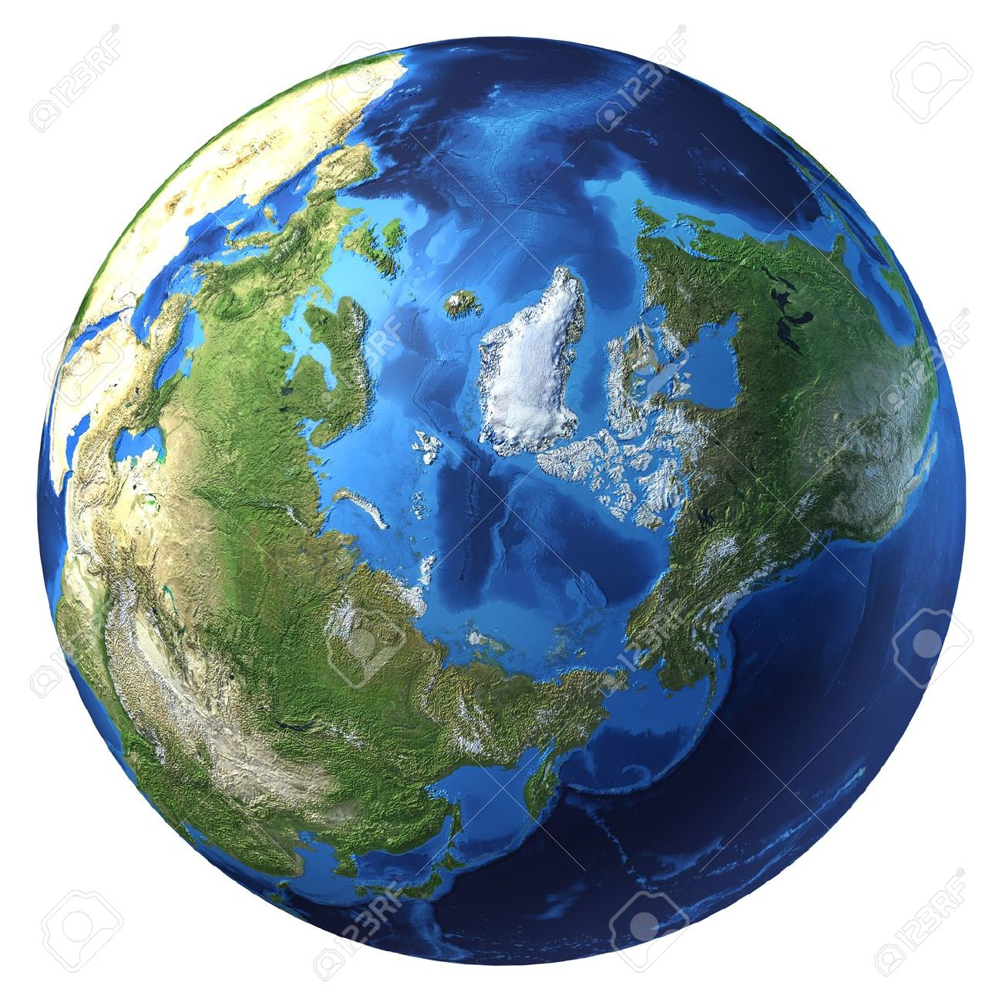](https://www.google.co.uk/url?sa=i&rct=j&q=&esrc=s&source=images&cd=&cad=rja&uact=8&ved=2ahUKEwj_-f-7wZ_dAhWEIcAKHTimCvQQjRx6BAgBEAU&url=https%3A%2F%2Fwww.123rf.com%2Fphoto_11779733_earth-globe-realistic-3-d-rendering-arctic-view-north-pole-on-white-background-.html&psig=AOvVaw0Cnh1xzT2sE2Xde3URIVZF&ust=1536087329010674)

Geography

We will be using a map to find the UK and countries within the Arctic Circle, and comparing lives in the UK and the Polar Regions. We will be learning about polar explorers and thinking about what we would need in order to survive in other parts of the world. We will also be exploring the climate, physical features and wildlife that inhabit the Polar Regions.

Computing

We will be programming Bee-bots to follow a set of simple instructions. We will also be completing activities on Purple Mash throughout the term.

Art

Art will link with Science this term, and children will have opportunity to use a range of different mediums this term including watercolour, pastels and paints.

D.T

In the second half of the Autumn term, the children will be architects with a ‘Grand Designs’ theme, designing, making and evaluating their own model homes.

Music

Class 2 will be learning the Ocarina with Mrs Tan on Tuesdays.

If you have any questions or just want to say hello, please feel free to pop in after school.

Mr Mavin

Class 2 Teacher

Class 2 Autumn Term