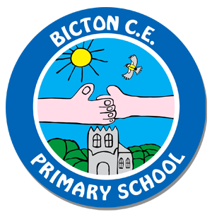
CLASS 4 – SUMMER 2018
NEWSLETTER

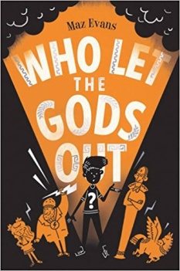
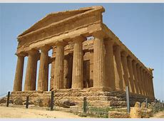
English
This term, we will be studying the novel ‘Who let the God’s out?’ by Maz Evans. It is linked to our topic on Ancient Greece and our English lessons will be based on exploring the many elements of the story. Children will again have access to a copy of the story in class so they can follow it themselves. We will be covering a range of text types including arguments & debates, poetry, descriptive writing, leaflets and character studies. We will also be working on different aspects of spellings and grammar each week linked to the story.

Maths
The topics we will cover in maths this term will be decimals, geometry: properties of shapes, geometry: position & direction, measures: converting units and measures: volume.

Topics
History - our topic this term is ‘Ancient Greece’. We will be learning about how the Greeks used to live including; looking at ancient artefacts, religion, gods and goddesses, clothing, schools, government and the Olympic games. We also hope to have a ‘Greek Day’ and if possible a visit a museum at the end of term. A lot of our art work and DT will also link to Ancient Greece.
Science - we will be exploring the topics of ‘Living things and their habitats’ and ‘Light’.
RE - we will be focussing on the key questions: ‘When Jesus left, what was the impact of Pentecost?’ and ‘The Creation/Fall’.

P.E.
Our P.E. sessions for this term are on Tuesdays and Thursdays for the first half term. On a Tuesday the children will be doing ball games and on Thursday they will be swimming (relevant kit will need to brought in each week for this – please see letter). After half term they will be doing games/dance and athletics. It is a good idea to keep P.E. kit in school for the whole week, to allow for any unforeseen changes to the timetable.

Spellings and Homework
Spellings and homework will continue to be given out on Fridays. Spellings will be tested each Friday morning and homework needs to be handed in by the following Wednesday every week.

We are looking forward to another fun and challenging term with Class 4 and hope that the children will enjoy all of the new topics. If you have any further questions, please do not hesitate to ask.

Mrs Thomas and Mr Mavin

