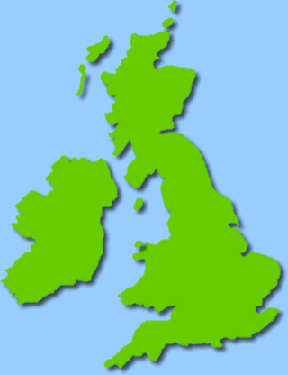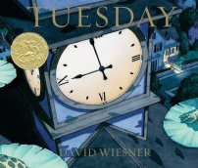

**Class 3 Curriculum Letter**

**Spring 2018**

Welcome back! I hope you had a lovely Christmas!

**Art:** We will be learning about landscapes and cityscapes this term, focusing on how to create these through different mediums.

**PE:** The children will be doing fitness and dance in PE this term and this will take place every **Wednesday** and **Thursday.** As always it is important your child has both a full indoor and outdoor kit in school (this includes trainers) so that they are prepared for all types of weather.

**RE:** We will be looking at our gospel unit of work to begin with, focusing on the question ‘What is the good news Jesus brings?’ We will be learning about what Christians believe the ‘good news’ is, how this affects their daily lives and what we can learn from it for our own lives. We will then move onto our salvation unit of work after half term, which focuses on the Easter story.

**Computing:** We will be learning about computer programming this term and will be using the program scratch to help us learn all about algorithms.

**Spellings:** Spellings will continue to be given out on a Friday and will be tested the following Friday as usual. As part of their homework each week, the children are expected to put each of their spelling words into sentences. This will be marked every Friday after their spelling test.

**Homework:** Other homework will be given out regularly throughout the term and may be linked to any area of the curriculum. It is important that this is completed in order to reinforce current or prior learning. The children are expected to read regularly at home. As the Year 2 children are preparing for end of key stage assessments, it is important that they continue to read aloud regularly with an adult and that this is recorded in their reading record.

**English:** This term we are going to be using the book ‘Tuesday’ by David Wiesner as our stimulus for creative writing. We will be using this to help us develop our understanding of how to write recounts, narratives, newspaper reports and play scripts.

We will also be having weekly grammar lessons focusing this term on past and present tense, direct speech, conjunctions, adverbs, prepositions, fronted adverbials, nouns and pronouns and sentences with different forms.

**Maths:** In Maths we will be learning and revising:

* Addition and subtraction
* Measurement – length, height, capacity, mass, money and time.
* Shape – including position and direction.
* Statistics.

**Geography:** Our topic this term is ‘Our Kingdom’. This will be an in depth study of the United Kingdom. We will be learning about the four countries of the United Kingdom, looking at both human and physical features of these. We will learn about major cities of the UK, with a particular focus on London.

**Science:** Our Science topic this term is ‘Animals Including Humans ‘. We will learn about the importance of a balanced diet, the human skeleton and human muscles. We will also learn how to group animals into vertebrates and invertebrates.

**Design and Technology:** In keeping with our ‘UK’ topic, we will be designing, making and evaluating our very own ‘British Afternoon Tea’.

**French:** We will be learning how to talk about our friends and family as well as revising key areas such as numbers, colours and the alphabet.

**PSHE:** Our topic this term will be ‘Going for Goals’ where we will be thinking about how to set realistic goals and how to persevere and achieve them.

We are looking forward to the term ahead and bringing all of the above to life in the classroom! If you have any questions please do not hesitate to come and see me. Kind regards, Miss Barratt.