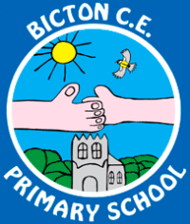

Our topic for the Spring Term is **North America.**

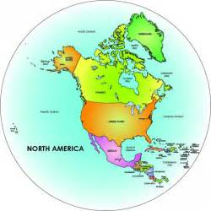

**What to Remember**

Spellings: New spellings will be set on Fridays. Spelling test will be every Friday morning.

Homework: Homework will continue to be set on Fridays. This will be based on either our current learning in maths, spelling/punctuation/grammar, a reading comprehension, or a piece of work linked to our topic. Homework will usually be due in by the following **Wednesday.** Year 6 may also be given a SAT-specific homework task to complete.

PE: PE will continue to be on **Thursdays and Fridays** this term. Please ensure PE kit is in school on these days.

Reading Books: Please make sure your child reads their reading book regularly at home. Please write a small comment in their reading journal. We will listen to your child read at school at least once a week in a group guided reading session so please ensure your child brings their book and reading record to school every day.

Website: Remember our Class 5 page can be found following the links on the school website. This will be updated regularly with photographs and important information.

Please do not hesitate to come and see me if you would like anything clarifying.

Miss Carr

Class 5 Teacher

English

In English we will be continue learning through a novel study, which this term will be ‘Phoenix’ by SF Said. This is a challenging text which will offer a wide variety of writing opportunities. This term we will be writing newspaper articles, narrative recounts, letters, non-chronological reports and persuasive writing.

Spellings this term will focus on prefixes and suffixes.

We will also continue our weekly discrete grammar session, this term focusing on verb forms, synonyms and antonyms, recognising word types, pronouns, apostrophes and commas.

Maths

In maths we will be learning and revising:

* Algebra
* Converting measurements
* Perimeter, area and volume
* Ratio
* Properties of shapes
* Statistics.

We will also continue revising instant recall of times tables, and the core calculations.

Science

In Science we will be learning about Earth and Space in the first half of the term, followed by forces in the second half term.

R.E

In the first half of the term we will focus on Gospel in Christianity, and the second half will be focusing on Salvation in Christianity.

**Welcome back!**

**I hope you have all had a wonderful Christmas and New Year.**

Geography

North America – identifying countries, climates and geographical features of North America. Exploring cities and time zones, and comparing a region in North America with a region in the UK.

Computing

Investigating how data travels across the world, how we can protect our data, investigating commonly used websites, investigating and designing a database. We will also be learning about how to prevent cyberbullying.

D.T/Art

Researching Native American history. Designing and creating images to represent ourselves. Designing and making a Native American dreamcatcher and headwear worn in different cultures and traditions.

MFL

Engaging in short exchanges when ‘going to the shop’, telling the time, and describing the order of events.

Music

Playing a brass instrument taught by peripatetic music teacher, composing short tunes.

Class 5 Spring Term