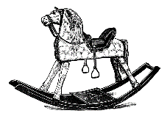
Autumn Term 2017 - ‘Toys Past and Present’
Curriculum Letter

Dear Parents and Carers,
I hope you had a lovely summer holiday and are looking forward to the new school year! I am looking forward to hearing the children’s stories of their adventures whilst they have been away.
English
We will be following the Read Write Inc program for Phonics and English this year. This incorporates phonics, handwriting, guided reading, spelling and independent writing. The children will be given many opportunities to write at length and encouraged to use finger spaces, capital letters, full stops and adjectives to extend their writing.
Maths
To begin with we will develop our understanding of numbers and how these can be represented in a range of different ways. The children will also revise and learn new addition and subtraction skills this half term.
Science
Our topic in Science this term is ‘Seasonal Changes’. The children will observe the changes across the four seasons. They will also observe and describe weather associated with the seasons and how the day length varies.
Topic
This term our topic is ‘Toys - Past and Present’. We will be discussing our favourite toys and describing them to our friends. The children will also look at a range of toys from the past and discuss how these differ from their toys today. We will also investigate how the materials used to make toys have changed over the years.
Art
Our Art lessons will link with the Science topic ‘Seasonal Changes’ this term. The children will have opportunities to use a range of different mediums such as coloured pencils, watercolours and pastels.

D&T
The children will investigate different leavers and sliders in D & T this term. They will then use their skills to make moving pictures.
PSHE
During PSHE we will be looking at ‘new beginnings’ during the first half of the term, followed by ‘getting on and falling out’ later in the term.
PE
PE will be on Monday and Wednesday afternoons this term. Please could you ensure your child has their PE kit in school every day in case this changes. Monday lessons will be Dance and Wednesday lessons will be Games.
Computing
Children in Class 2 will have lots of access to the laptops and Ipads this term, to develop their computing skills as well as carrying out research. They will develop their programming with Beebots and we will be discussing the importance of E-safety.
RE
In RE we will be focussing on Judaism. The children will learn how Jewish people celebrate their faith.
Spellings
The children will be provided with a spelling book at the end of the week with a set of new spellings. These will be tested the following Friday which will continue throughout the year. The spellings link with phonics work we have been doing in class.
Homework
Homework will be given to children as and when, linked with different areas of the curriculum. Please continue to read with your child at home and fill in their reading record accordingly.
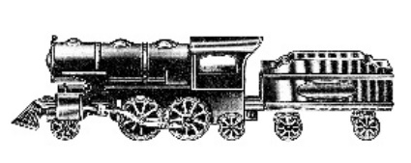
If you have any questions please do not hesitate to come and see me before or after school.
Kind regards,
Miss Edwards.

