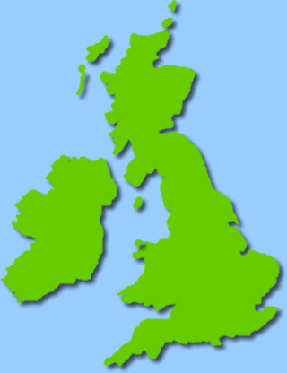

**Class 3 Curriculum Letter**

**Autumn 2016**

Welcome back! I hope you had a lovely summer!

**Design & Technology:** Our topic for this term is ‘structures ‘. We will develop our understanding of frame structures and how they can be strengthened and stiffened. We will discover information about a key event involving a kite that helped shape the world and then we will design, make and evaluate our own kites.

**PE:** Children will be doing gymnastics and invasion games in PE this term and this will take place every **Tuesday** and **Friday.** As always it is important your child has both indoor and outdoor kit in school so that they are prepared for all types of weather.

**RE:** We will be finding out the answer to the question ‘Who are our neighbours?” at the beginning of the term. We will look at what the bible says about our neighbours and how we should treat them. In the second half term we will be looking at what the Christmas story can teach us about who Jesus is.

**PSHE:** We will be looking at ‘new beginnings’ at the start of the term as well as looking at friendships and targets for the year.

**Computing:** We will be learning about the internet this term, key features of it as well as how to ensure we stay safe when using it.

**Spellings:** Spellings will continue to be given out on a Friday and will be tested the following Friday as usual. Particularly at this point in the year, it is important to revise spelling strategies taught previously to begin with so please bear this in mind when your child receives their weekly spellings. It is important for children to not only learn their weekly spellings but continue to use the strategies they have learned to their independent writing.

**Homework:** Homework will be given out regularly throughout the term and may be linked to any area of the curriculum. Please continue to read with your child and fill out their reading record regularly.

**English:** We are beginning the term with a study of a significant author – Roald Dahl. We will be looking at his life as well as his characters, stories and poems. This will help to inspire our own writing allowing us to develop our own stories and poems as well as giving us the opportunity to develop our understanding of non-fiction genres such as newspaper reports and information texts. Reading Roald Dahl stories together at home could help support your child with our work and help develop their enthusiasm for the topic.

**Maths:** We will begin by developing our understanding of place value in 3 and 4 digit numbers, as well as in money. Then we will revise and learn new mental and written methods for addition, subtraction, multiplication and division. We always appreciate your support in helping your child learn their times tables and supporting with any homework they are given.

**Geography:** Our topic this term is ‘Our Kingdom’. This will be an in depth study of the UK. We will be learning about major cities, counties and regions as well as discovering human and physical features of these.

**Science:** Our Science topic this term is ‘Forces and Magnets’. We will be exploring magnets and their effects through lots of practical work and investigations. The children will also develop their understanding of friction and the effect this has.

**Art:** In keeping with our ‘UK’ topic, we will be learning about British artists and their artistic styles. This will inspire us to create our own art work and explore a variety of techniques and materials.

**French:** We will be learning how to talk about ourselves and how to respond to questions.

We are looking forward to the term ahead and bringing all of the above to life in the classroom! If you have any questions please do not hesitate to come and see me. Kind regards, Miss Barratt.