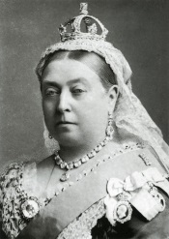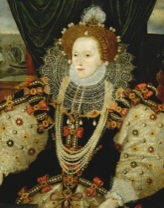

**Class 3 Curriculum Letter**

**Summer 2016**

Welcome back! I hope you had a lovely Easter holiday!

**Design & Technology:** We will be linking our D&T to our science work on keeping our body healthy. Children will therefore design and make a healthy snack/meal.

**PE:** Children will be learning tag rugby and gymnastics in PE this term and this will take place every **Tuesday** and **Friday.** As always it is important your child has both indoor and outdoor kit in school so that they are prepared for all types of weather.

**RE:** We will be finding out the answer to the question ‘Why did Jesus tell Parables?” this term. We will be reading the parables Jesus told, acting them out, discussing character’s feelings and discussing what Jesus was teaching people about God through telling them.

**PSHE:** We will be continuing our topic ‘Say no to bullying’ as well as looking at ‘Changes’ towards the end of the term, which is to do with new challenges.

**Computing:** We will be learning about computer programming this term as well as touching on internet safety and continuing to develop our basic computer and word processing skills.

**Spellings:** Spellings will continue to be given out on a Friday and will be tested the following Friday as usual. Just so you are aware, some of the groups will be receiving homophones as their spellings over the next few weeks. Although the spellings themselves may appear easy, the focus is on the children learning the meaning of the word and knowing which spelling to use for which meaning. Therefore when you are practising spellings with your children could you please ensure you put them into a sentence in order to help their understanding.

**English:** This term in literacy we are studying non-chronological reports. We will be looking at key features of these texts before planning and writing our own. This will allow children to develop their understanding of non-fiction writing. We will also be continuing with story writing features and developing our creative writing skills. A poetry unit will also be covered during this term.

**Maths:** We are continuing to develop our understanding of formal written methods for addition and subtraction as well as applying these skills to other areas such as money and measurement. We will be revising skills learned already this year and practising and improving these in a variety of contexts.

**History:** Our topic this term is ‘British Monarchs’. We will be looking at British Monarchs such as Queen Elizabeth I and Queen Victoria and will discover the impact they had on Britain. The children will make comparisons between life in the past and life in Britain today.

**Science:** Our Science topic this term is ‘Animals including Humans’. We will be looking at the human body and learning about the skeleton, muscles and ways to keep our body healthy. We will also be learning about the life cycles of other animals including frogs and butterflies.

**Art:** We will be linking our artwork to our topic with the children creating collages of different time periods within Britain.

We are looking forward to the term ahead and bringing all of the above to life in the classroom! If you have any questions then please do not hesitate to come and see me. Kind regards, Miss Barratt.